RAG Ingestion through Mongo Vector Index DB:

Created Vector Index:
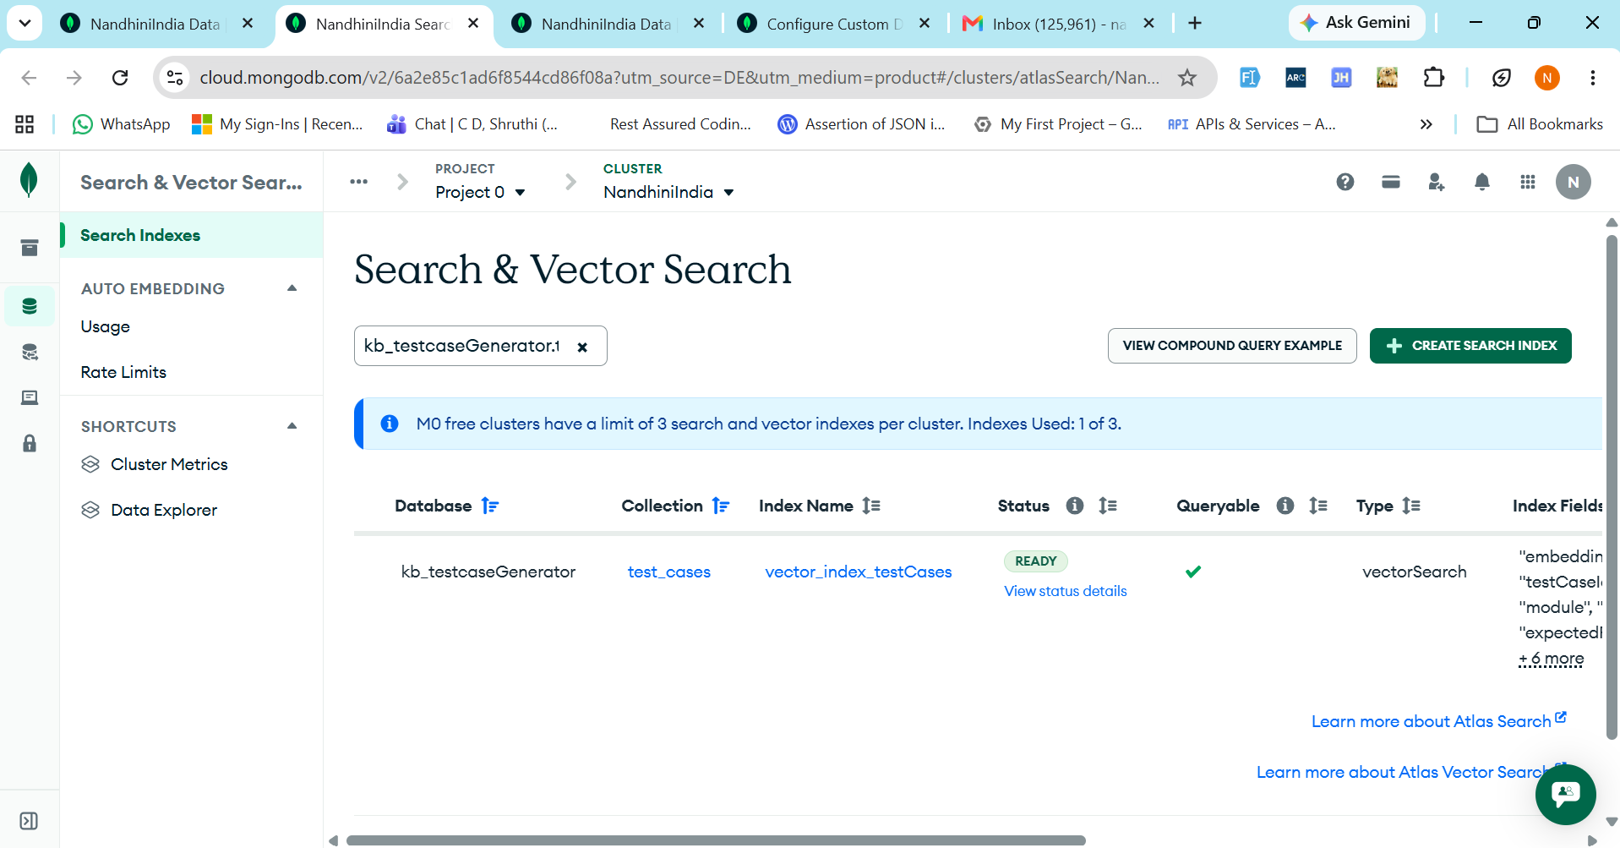

RAG Ingestion Langflow created:
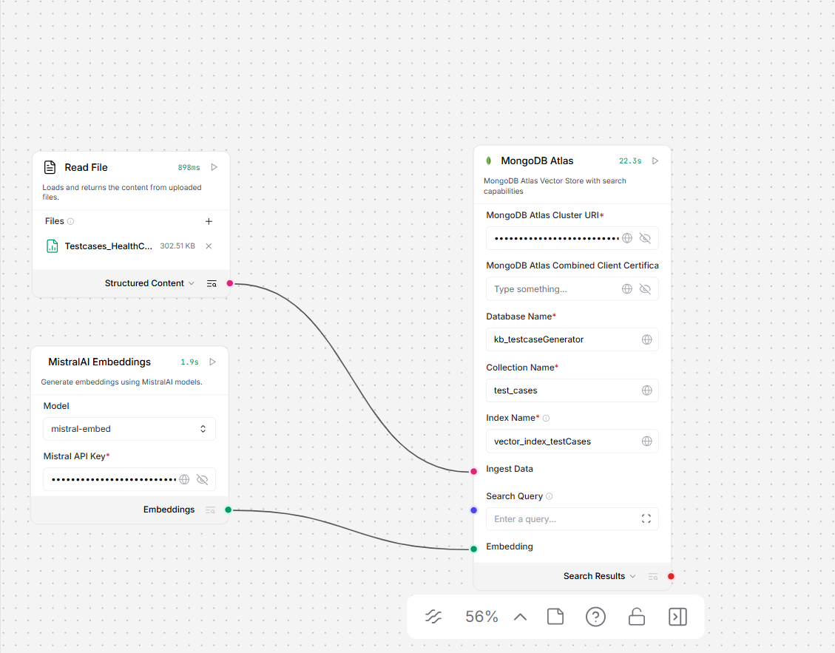

500 test cases have been ingested in MongoDB:
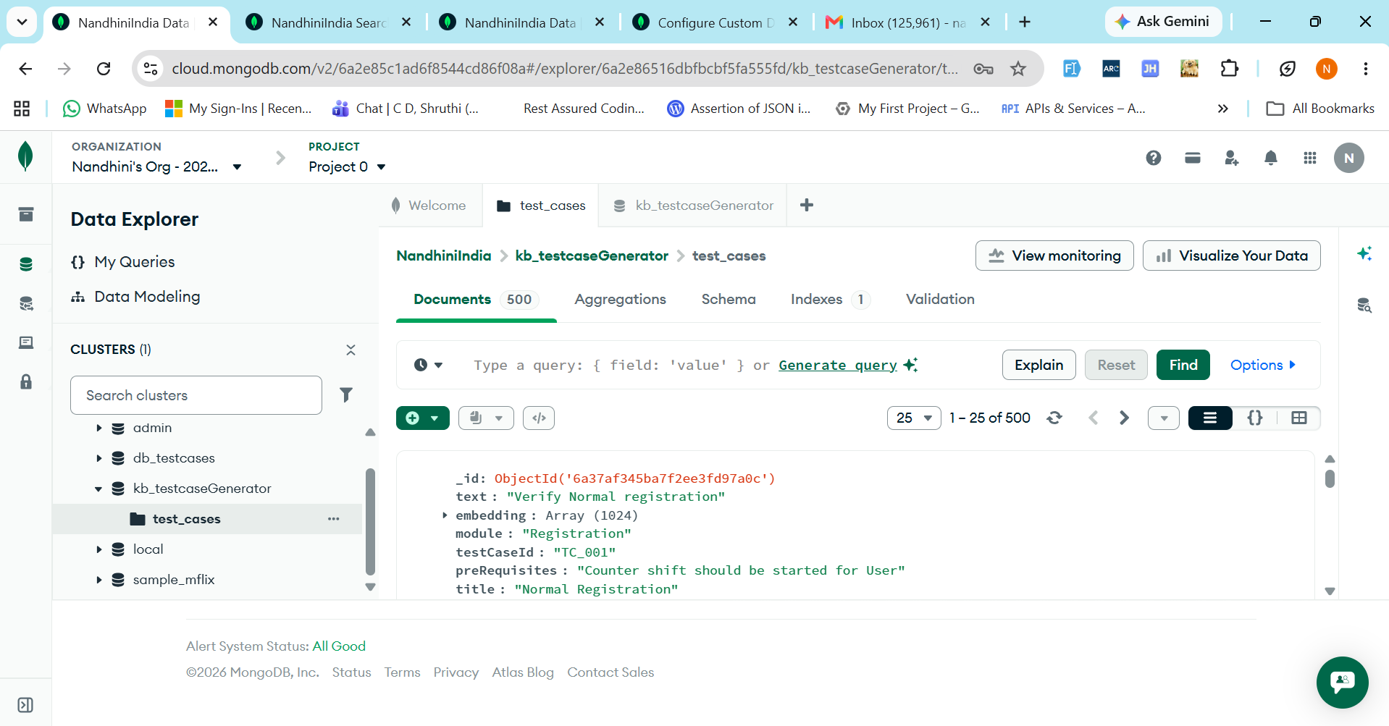

RAG Retrieval process in Langflow:

Querying for Test cases for Registration with top k records (10):
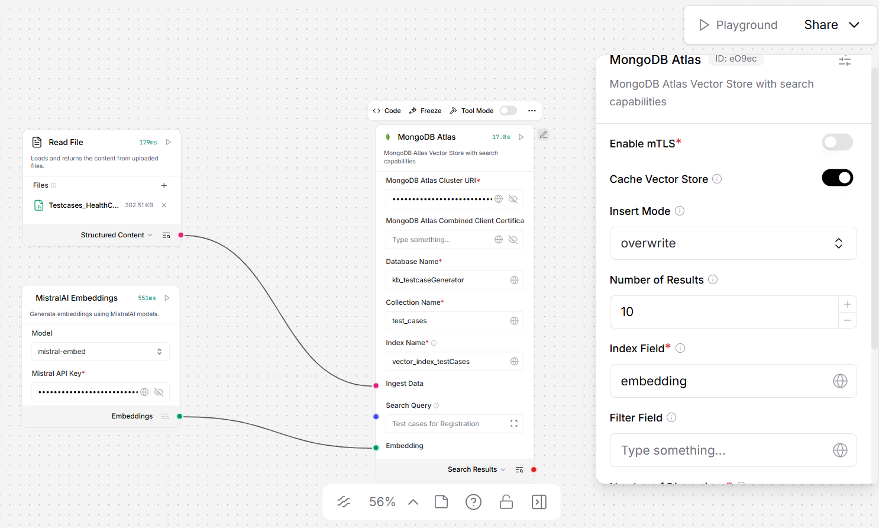

Retrieved top k records (10) from the vector DB:

